**IBM ASSIGNMENT-1 HOME AUTOMATION**

**CIRCUIT DIAGRAM:**

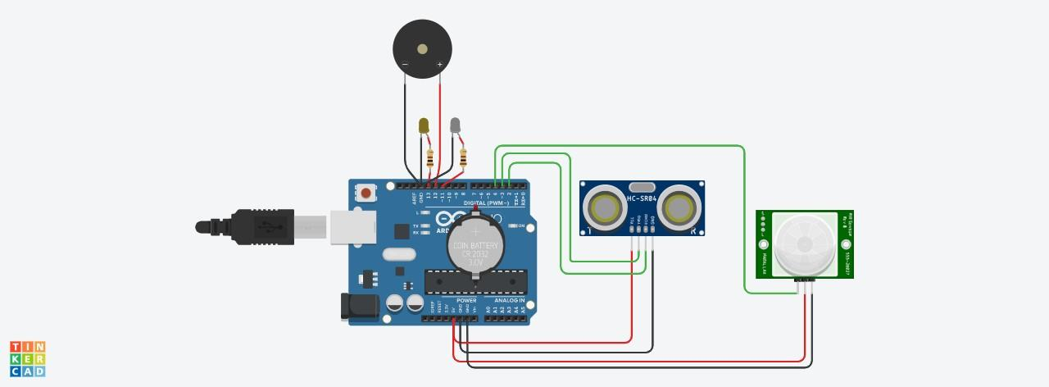

**CODE:**

void setup()

{

pinMode(11, OUTPUT);

pinMode(12, OUTPUT);

pinMode(13,OUTPUT);

pinMode(2,INPUT);

pinMode(3, OUTPUT);

pinMode(4,INPUT);

Serial.begin(1000);

}

void loop()

{

int a=digitalRead(4);

//Reads the motion in the room.

//------------------------------------------

if(a)

{digitalWrite(11,HIGH);

//if moment is detected the light will glow for 5 minutes.

delay(5000);//5 minutes is taken as 5 seconds.

Serial.println("\n\nmotion in the room,lights is ON");

}

else

{

digitalWrite(11,LOW);

//if there is no motion after 5 minutes the light turns off .

Serial.println("\n\nNo motion,light is OFF");

}

//-------------------------------------------------------

digitalWrite(3,LOW);//no gen. of pulse of sound

digitalWrite(3,HIGH);//gen, of pulse of sound

delayMicroseconds(5);//10ms of sound pulse.

digitalWrite(3,LOW);//ultrasonic sensor is off.

float p=pulseIn(2,HIGH);//receives the reflected signal.

float d=(p*0.0343)/2;//calculate distance of the water level.;

if(d<50)

{

tone(12,500);//the water tank is full is indicated

//using a buzzer.

Serial.println("\n\nThe Water Tank is full");

}

else if (d>250)

{

noTone(12);

digitalWrite(13,HIGH);//if the water tank is empty,yellow

//light gets on indicating tank is empty.Serial.println("\n\nThe Water Tank is empty");

}

else

{

noTone(12);

digitalWrite(13,LOW);//the water level is normal.

Serial.println("\n\nThere is Water in the water Tank");

}

}

**OUTPUT:**

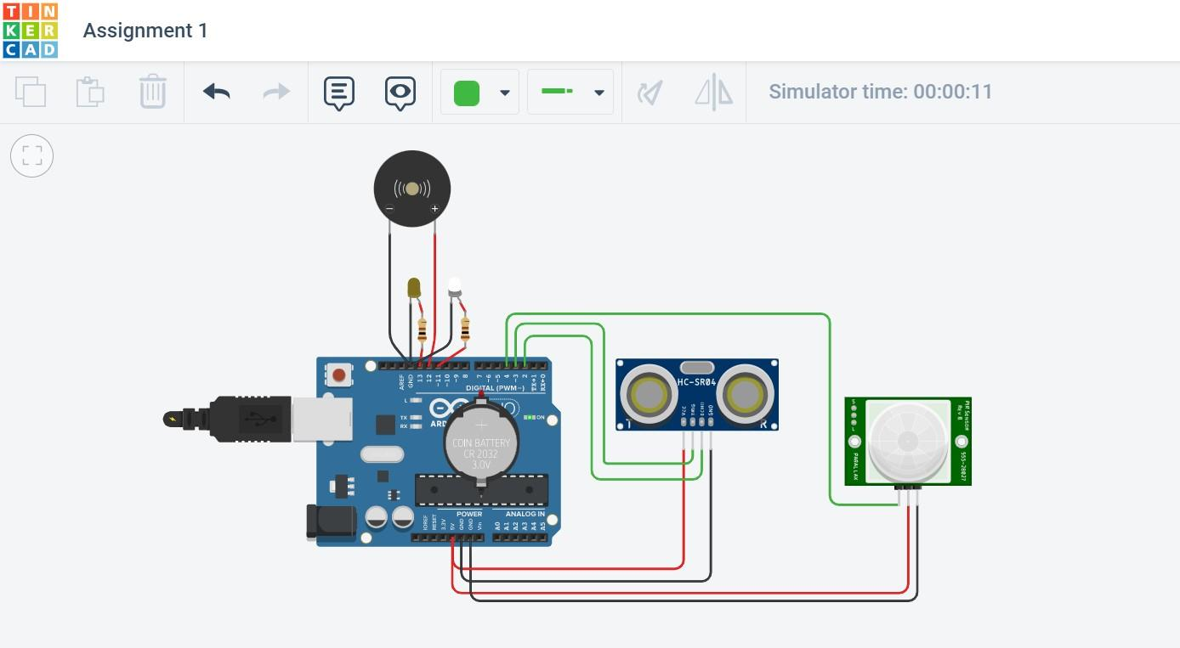

**TEAM LEADER:** Rajalakshmi V

**TEAM MEMBERS:** Hari Prasath.T, Porselvi.S, Muthu Sathish.P